**İSPANYA GEZİSİ**

**FİRST DAY**

On the first day, we got up in the morning and had breakfast happily, then we went with the arrow and I had friends there. we played volleyball with them and it was quite fun, we laughed together and had fun. then we went canoeing and we were happy. we went home, ate pizza and after talking a bit with EMMA we went to sleep.

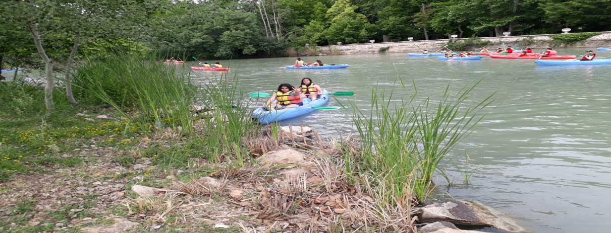

**SECOND DAY**

On the second day, we did the same activities in the morning. and we went to school together we were happy we went bowling after school and it was so much fun. then we went home and chatted and slept.

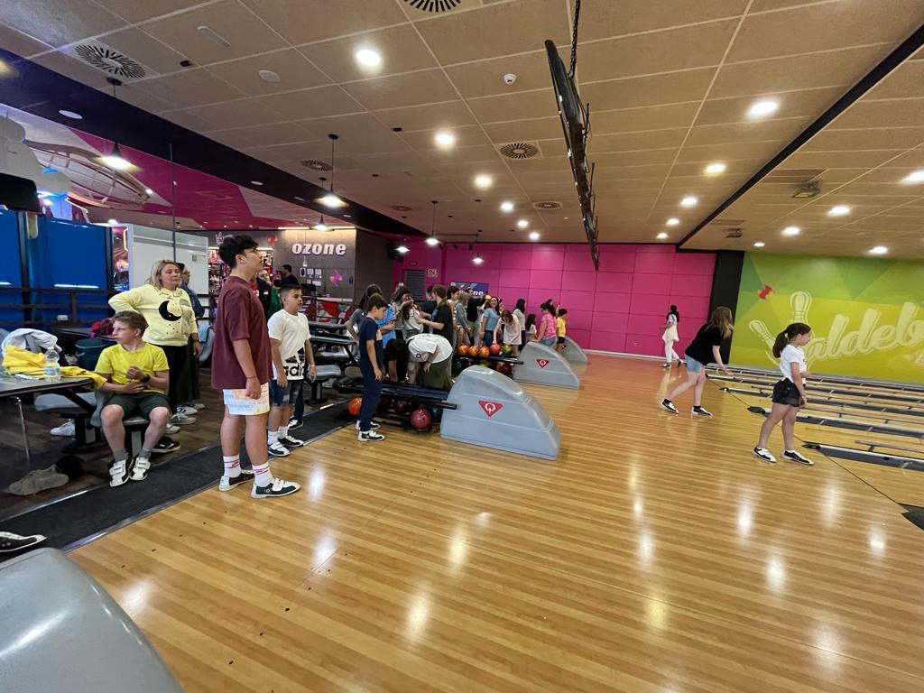

**THİRD DAY**

We went to Madrid on the third day, it was a lot of fun, we shopped there and took pictures. It was also one of those moments when I was at the bottom of the fun. We returned home and fell asleep as soon as we got back.

**FOURTH DAY**

On the fourth day, we went toledo, it had a lot of historical sites. there were many reasons to be happy. We went to the party after toledo. it was very fun. Then we returned home and slept.

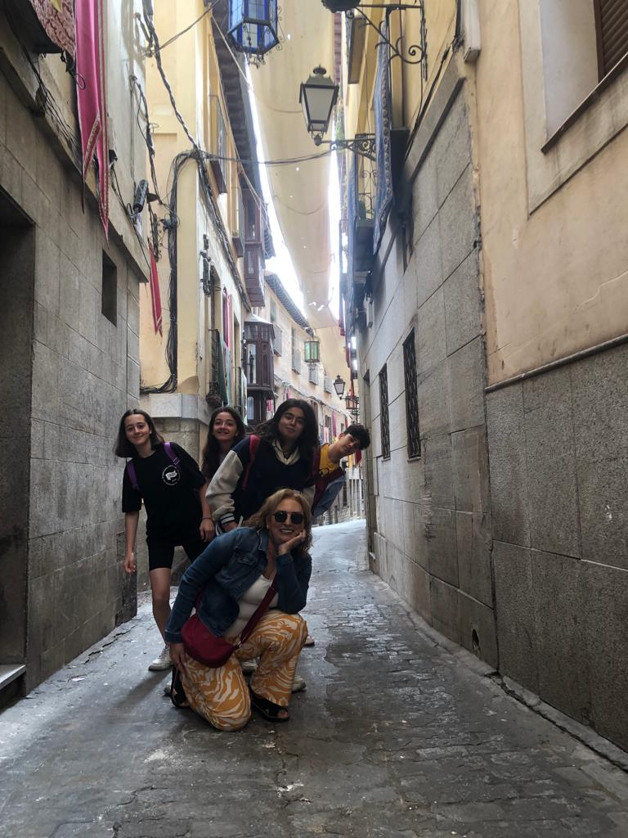

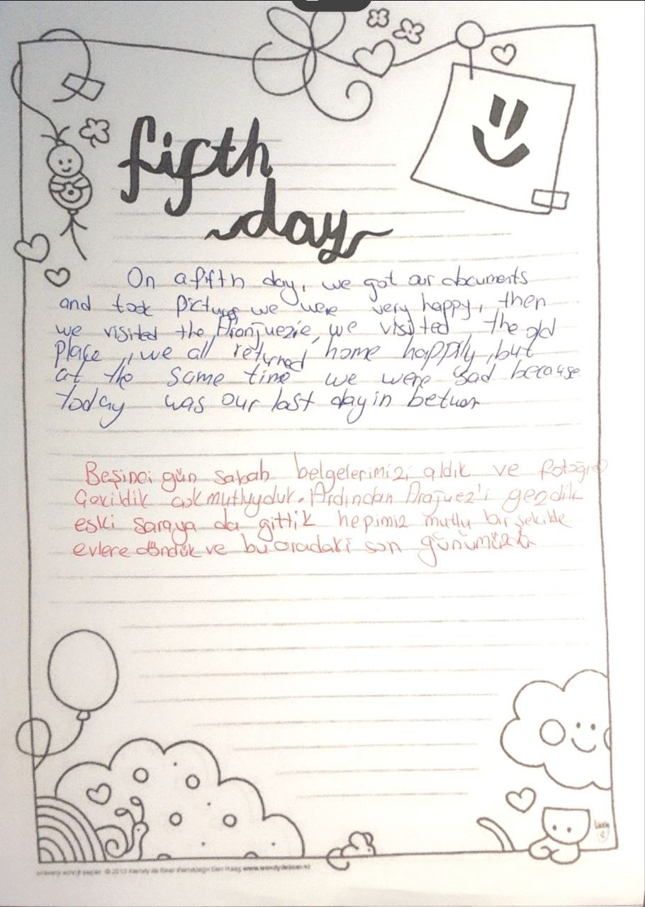

**Meryem Masal TÜRKMENOĞLU June 2023**