Spanish Diaries by Nisa Civaner

*18 May 2023*

Thursday

} Hello, I decided to write my Spain diaries 3 days in advance because I am both very excited and extremely happy. We had a meeting with my friend Elif, Paula and her mother, whom I will stay with today. We all introduced ourselves. I learned that Paula's favorite color is pink and she is 10 years old and they have two dogs and a house with a private garden. Since we just met, we were a little shy at the meeting, but I think it's very natural. After our meeting with Paula and her mother, Sevcan teacher, Rüzgar, Masal, Elif and I held an Erasmus meeting. Now we are going, it will be an experience for us, İ-N-A-N-I-L-M-A-Z, anyway, after we talked a little about what to do and what to take, we ended the meeting that day.

*20 May 2023*

Saturday

} Hi, today is the 20th so the thing is we're going to Spain tomorrow. I am very excited. If you've seen me, you'd understand, because I always tell people I know (or maybe even a little) that I'm going to Spain. Today I said goodbye to my uncle and grandmother, we had already said goodbye to my grandfather in the morning. After the lessons were over, my dear friend Duru and I went somewhere to spend time before I went. After spending some time and playing, we said goodbye and dispersed to the houses. In the evening, me and my mother checked the list to complete my shortcomings in my suitcase and I can't say "I slept" because I couldn't sleep, but at least I could rest for a few hours. At around 07:00 in the morning, my mother, father and I will go to Izmir/Adnan Menderes Airport. See you on the road tomorrow.

*21 May 2023*

Sunday

} I can't believe it, but we're on the plane now. Our group: Elif, me, Rüzgar,Masal, Sevan teacher and Gaye teacher also; We will take off towards Istanbul/Sabiha Gökçen Airport with Yaren, Aise, Zeynep, Zafer, Emre, Berna and their three instructors from the Aydın/Söke group. We said goodbye to our families in the morning (I may have cried a little). After we checked in and checked in, we gave our luggage and took our backpacks and food bags with us, and after waiting for 1 hour we boarded the plane. We ate the food we took with us while waiting for the plane. I'm still dreamy and I might pass out. I know Istanbul is a very short distance away, but I am very excited about Spain, which we will go after. Anyway, let me talk about what we did on the plane, I had a little fear and stress when I took off, although I had boarded the plane many times before, but over time, that stress disappeared and flew away, then I wrote a little diary, played a game (Elif and I) and watched outside, I was lucky that I came across the seat by the window. and we were side by side with Elif. Our plane will land around 10:00, see you for now :)

}}Sorry, I forgot to write while waiting for our Belgian friends. It's 16.00 and we're on a flight to Madrid right now, our journey will take about 4 hours, so we're going to have some food, look around, play some games and spend time. I am very happy and as a 13-year-old person, I will never, ever forget this moment, and I will never disturb my peace, I will not neglect to enjoy the moment! It's 18:41 now, unfortunately, sometimes when I let the events and myself flow, I have to write my diary intermittently, but whatever, I have more fun because when I write about the good things I do, I feel happy and feel like I'm living that moment again. Anyway, back to the main subject, we will drop the Aydın/Söke group and my teachers at the hotel, and we will go to the hotel's door, where we will meet with our families. We will arrive at the end of the 40-minute road. Together with Elif, we are very excited and a little nervous to meet Paula and her family. I feel in my heart that this year will be the year of many firsts in my life. I hope we can get along well. See you tomorrow (^ < ^)

*22 May 2023*

Monday

} Today in Madrid, the school was introduced and teachers and students were given badges. Of course, I got into the subject a bit fast. First of all, "Good morning" Paula and we stayed at around 07.20 to go to school today, had breakfast at home and went to school. Her mother Mari is driving us to school. Although she is a nurse, she got permission for us and takes us to and from school. As you can see, the family we stay in consists of very understanding individuals; On the evening of the day we got off the bus and met with our families, Mari (where people were called by their names) said to Elif and me "if you need anything, you can easily tell me girls" and we really liked it ;) Returning to the main topic, as I said, after the name tags were given, the school promotion event started with the hosts. Paula introduced us to the cafeteria, classrooms and the garden. I think their schools are neat, big and spacious, and the teachers are very friendly. Afterwards, they gave us a concert with flute, we liked it very much. Paula and we are a little shy, but I'm 100% sure we'll get along.

} We went home from school and put on our swimsuits and today....hold on....there was a canoeing event. Students and teachers gathered in that area to canoe on the river. They briefly showed us how to use it. We rode with Elif. After getting on, it was a complete comedy, Elif was ahead and I was behind, even though we went bump and it took a little time to learn, we finally succeeded (we were very happy and having a lot of fun). We were going to eat "Churro" and hot chocolate after the canoeing activity, but since the shop was closed, we decided to have breakfast there tomorrow morning. Goodnight.

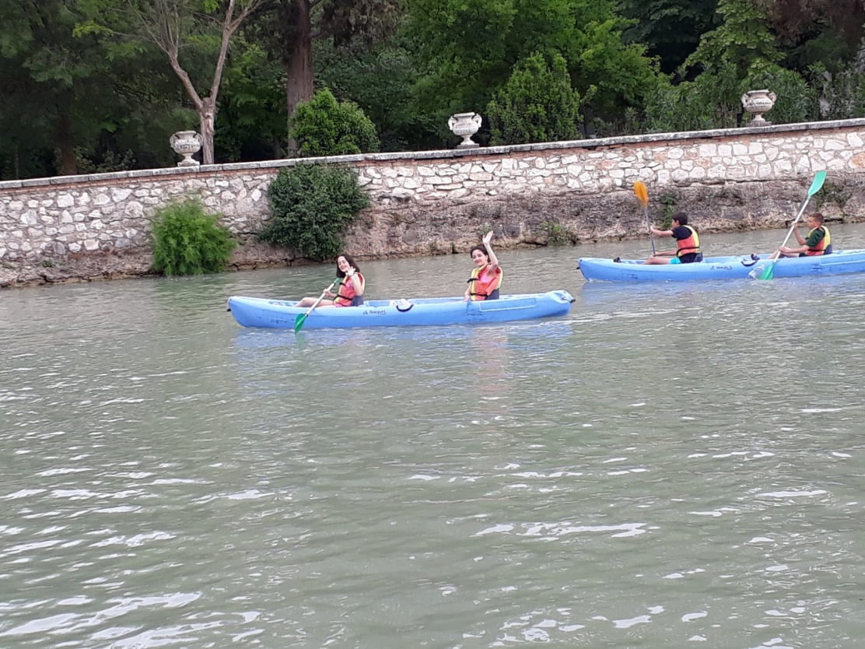

*23 May 2023*

Tuesday

} Good morning…today at the school cafeteria, our videobiographies (with English voice over) about ourselves; After a half hour break, we presented videobiographies of important people from Turkey. After that event was over, we waited for school leaving time to go to another family event. Elif, Paula and I waited in the gym for 2 hours. We stopped by the house to go bowling, which is one of the family activities, and got ready and set off. When we arrived, several families had already arrived, and when we arrived, we started bowling. Since I haven't played for a long time, I forgot a bit, but still I wasn't too bad "I think" Paula, her mother, me, Elif and Leire all competed together. Then we went to McDonald's. There was Natalia, her mother, Marcello and her mother, and we had dinner together. Then we returned home. [Additional info: 'Churro' tastes so good]

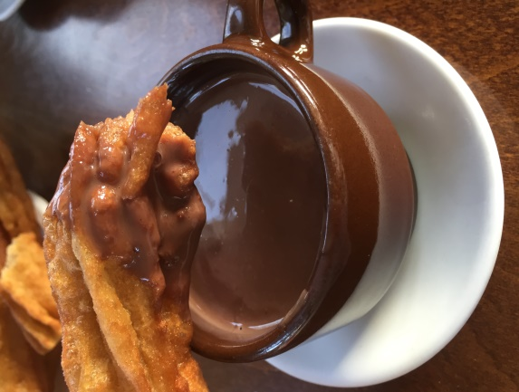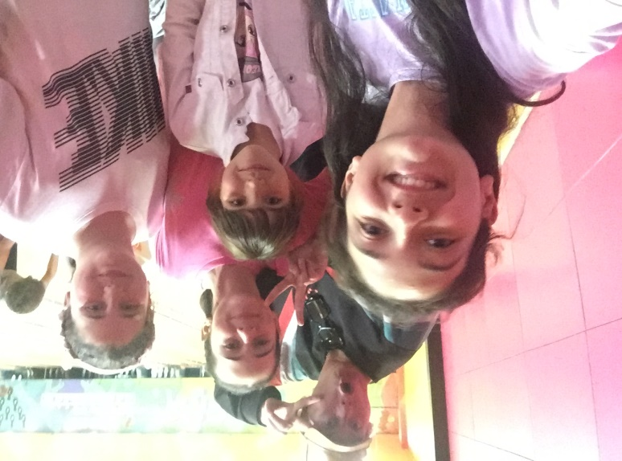

*24 May 2023*

Wednesday

} Today was a trip to Madrid. That's why we got up early in the morning, got picked up from school by buses, and after wandering around, we got on the double-decker bus. We were very excited. Together with Elif, we learned about Madrid while wearing our headphones on the double-decker bus and learning our own language from the audio recordings we wanted. In our free time, we drank coffee and did some shopping. When we got home, there was a barbecue party at Marcello's house, we went to that paw and had a lot of fun. Paula, Marcello, Natalia, Elif and I played Uno Flip. We had a lot of fun that day and were very tired; After the ice cream dinner, we went home and slept.

*25 May 2023*

Thursday

} Hello, we traveled to Toledo today, first we went to school, then we got on the bus, the road there was an escape distance, then we got off in the middle of the square. The real square did not actually exist, there was a market place, but because the journey attracted more tourists, the markets were removed and it was called the square. There were waiting in the square, buildings such as McDonald's and shopping stores, we wandered the inner streets a little because it was the holiday time, red, yellow or patterned cloths were hung on the windows and balconies. We took lots of photos with Elif and also examined the structure called the underground bath. Then we went to the main square. [New Information: The statue that the king built has a story, let me tell you now; The French soldiers who fell in love with this statue when they saw the statue of the captain of the French soldiers who had a statue made during the king's time asked this king, "Do you have a girlfriend?" they asked. They asked the king, "Come, I'll show you in the evening", he said "where I'm staying". Then the king got a little drunk with the French soldiers and their commanders in the evening, then had the statue of the king built and said, "Look, this is my lover". This was the story of the statue, whose authenticity was unknown. After that we wandered around the Jewish street. Blue square icons are placed at the corners of each of the structures they have built. We also took a look at the building where both Muslim, Christian and Jewish cultures were housed before, and then we completed our tour. From there we rested and toured the city with a train tour. Before that, we had some snacks and coffee. We went home and then rested at home for 2 hours and went to our family event restaurant and ended the day like this.

*26 May 2023*

Friday

} Hello, today there was a ceremony of participation certificate to be given within the scope of “Erasmus Digital Storytelling” project. After we finished, we set off from school to Aranjuez royal palace, visited the historical museum and it was a very bright place, it was forbidden to take cameras there, so let me tell you what I remember; the queen's chamber was a large and dreary room, and the king's chamber was large and dark, with the guests in the room with too many chairs and curtains. There were also many large and many small rooms for worship. The rooms were often like a hall. After we got out, the guide told us about the place and the garden. . A very strange thing, of course (if the peacock has never been seen before, which I have never seen before) we had the opportunity to see it up close. Then we toured the city by train (although this time there was no narration of a pre-recorded city). An additional piece of information was that the king would occasionally visit Bu's house. When the trip was over, we dispersed from school to houses, but before we dispersed, we held hands and shouted "oooo...Erasmus Family" in front of the school gate. We said goodbye to our friends who are not normally in the Erasmus program but met at school. Then (since the families had met before) we went to the Amusement Park with Natalia and Marcello, Paula, her friend mom and Mari. Elif and I had a lot of fun riding vehicles that have never reached such heights before in our lives and finally we ate french fries and nuggets. By the way, we taught Mari how to make coffee before she came to the amusement park. [Additional information: We had lunch at a restaurant today]. That's it for today.

*May 27, 2023*

Saturday

} We're Leaving Today ☹

} We got up early in the morning and took the bus we were going to go, we were a little late. Before we left Mari gave us her hats to Elif and me, we cried a little but we were still happy because they made those six days in my life beautiful, especially Paula, Mari, Antonio, also Natalia, Marcello, Claudia, Lola , Irache, Ximena, Carmen, Sara, Paula, Emma and my other esteemed teachers, I also extend my love to the Aydın/Söke group. I love them all because they have never left me alone, they are loving and friendly. After the bus journey, we got a little upset and started to wait for the plane for the four-hour Madrid-Istanbul/Sabiha Gökçen journey. When the time came, we sat down, wrote diaries, played games, took pictures and watched outside. After landing, we started to wait for the Istanbul-Izmir flight; We arrived at Izmir/Adnan Menderes Airport at around 23:00, albeit with a bit of a wait due to the first flight. When we got our luggage after landing, we broke out laughing when we realized that Elif and I had gone in the wrong direction and that we were in the expected place for the German luggage. Then we collected the suitcases from the “right place”, communicated and communicated with our families, and said goodbye to the Izmir/Söke group and headed towards the last door (of course, we didn't forget to join our hands and say “oooo..1..2..3...Turkey”. Everyone is out of the last control. It passed (normally there wouldn't be a check like X-ray this time) but the security guard turned me around and said "hey lady get through here please" and X-ray my suitcase, bag and I went through the security gate It was very funny because the people inside (because they didn't know about me at the time) At that time they were passing through the door. And they thought that the police had taken me, so my mother was surprised. Of course, I told them everything when I came. We laughed at this in a post and finally our families chatted and in a short time we said goodbye and returned home. On the way back, 6 days of excitement and separation. I experienced the sadness but I know that this is the case.It was the first page of the new book opened in my life... The adventure in Spain is now over.

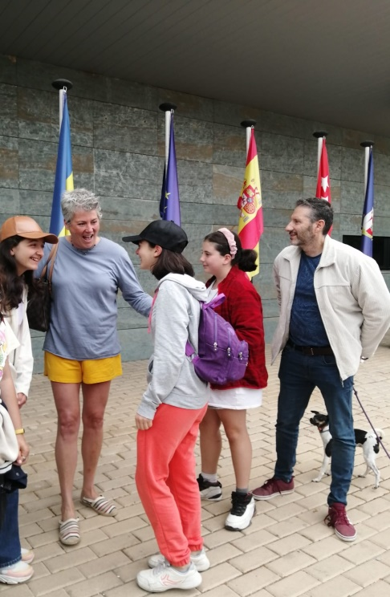 Nisa CİVANER , June 2023